XPT
NO:02 EDA – DATA CLEANING
AIM:
To inspect the Driver Standings dataset, identify its features and missing values, analyze its basic structure, and export the data into CSV, Excel, and SQLite database formats.
PROCEDURE:
1. Import the required libraries Pandas, OS, and SQLite3.
2. Specify the dataset path and identify the CSV file.
3. Load the Driver Standings CSV file using pd.read_csv().
4. Display the first five and last five records.
5. Inspect the dataset using .info(), .shape, .columns, and .dtypes.
6. Generate descriptive statistical information using .describe().
7. Identify missing values using .isnull().sum().
8. Check for duplicate records using .duplicated().sum().
9. Analyze driver-wise and finishing-position distributions.
10. Generate the correlation matrix for numerical attributes.
11. Export the DataFrame into CSV and Excel formats.
12. Connect to an SQLite database using sqlite3.
13. Store the DataFrame in an SQL table using .to_sql().
14. Close the database connection.
15. Display a confirmation message after successful file creation.

CODE:
import os
import pandas as pd
import sqlite3
# Dataset path
path = "/content"
print("Dataset path:", path)
print("\nFiles in dataset:")
print(os.listdir(path))
# Find CSV file automatically
csv_files = [f for f in os.listdir(path) if f.lower().endswith(".csv")]
if not csv_files:
raise FileNotFoundError("No CSV file found.")
csv_file = "driver_standings(1).csv"
print("\nCSV file:", csv_file)
# Load dataset
df = pd.read_csv(
os.path.join(path, csv_file),
low_memory=False
)
print("\nFirst 5 rows:")
display(df.head())

print("\nLast 5 rows:")
display(df.tail())
print("\nDataset information:")
df.info()
print("\nShape:")
print(df.shape)
print("\nColumns:")
print(df.columns.tolist())
print("\nData types:")
print(df.dtypes)
print("\nStatistical description:")
display(df.describe(include="all").T)
print("\nMissing values:")
display(df.isnull().sum().sort_values(ascending=False))
print("\nDuplicate rows:")
print(df.duplicated().sum())

print("\nTop 10 Driver IDs:")
display(df["driverId"].value_counts().head(10))
print("\nFinishing Positions:")
display(df["position"].value_counts().sort_index().head(10))
print("\nCorrelation:")
display(df.corr(numeric_only=True))
# Export CSV
df.to_csv("driver_standings.csv", index=False)
# Export Excel
df.to_excel("driver_standings.xlsx", index=False)
# SQLite database
conn = sqlite3.connect("driver_standings.db")
df.to_sql("driver_standings", conn, if_exists="replace", index=False)
conn.close()
print("\nCSV, Excel and SQLite database files created successfully.")

OUTPUT:
First 5 rows of the Driver Standings dataset:
driverStandingsId | raceId | driverId | points | position | positionText | wins
1 | 18 | 1 | 10.0 | 1 | 1 | 1
2 | 18 | 2 | 8.0 | 2 | 2 | 0
3 | 18 | 3 | 6.0 | 3 | 3 | 0
4 | 18 | 4 | 5.0 | 4 | 4 | 0
5 | 18 | 5 | 4.0 | 5 | 5 | 0

Dataset shape: 34,863 rows × 7 columns.
Duplicate rows: 0.
Total missing values: 0.

OUTPUT:
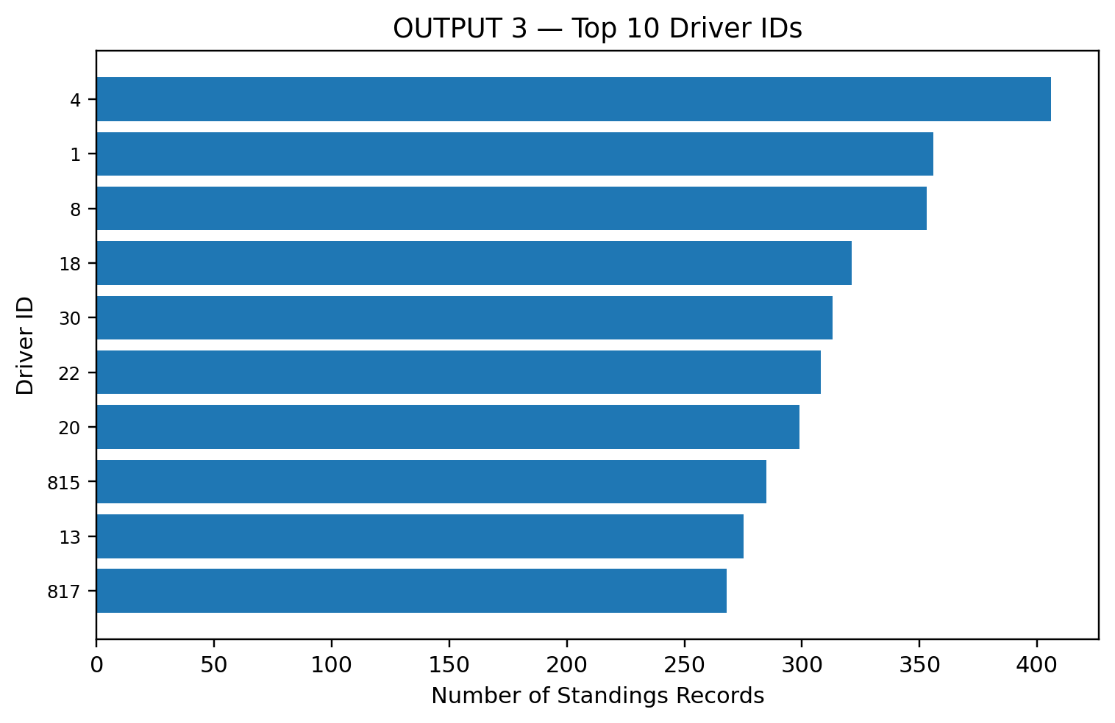
Result:
The Driver Standings dataset was successfully inspected, analyzed, and exported into CSV, Excel, and SQLite database formats.

